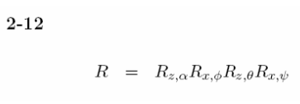

2-36

2-37

2-38

